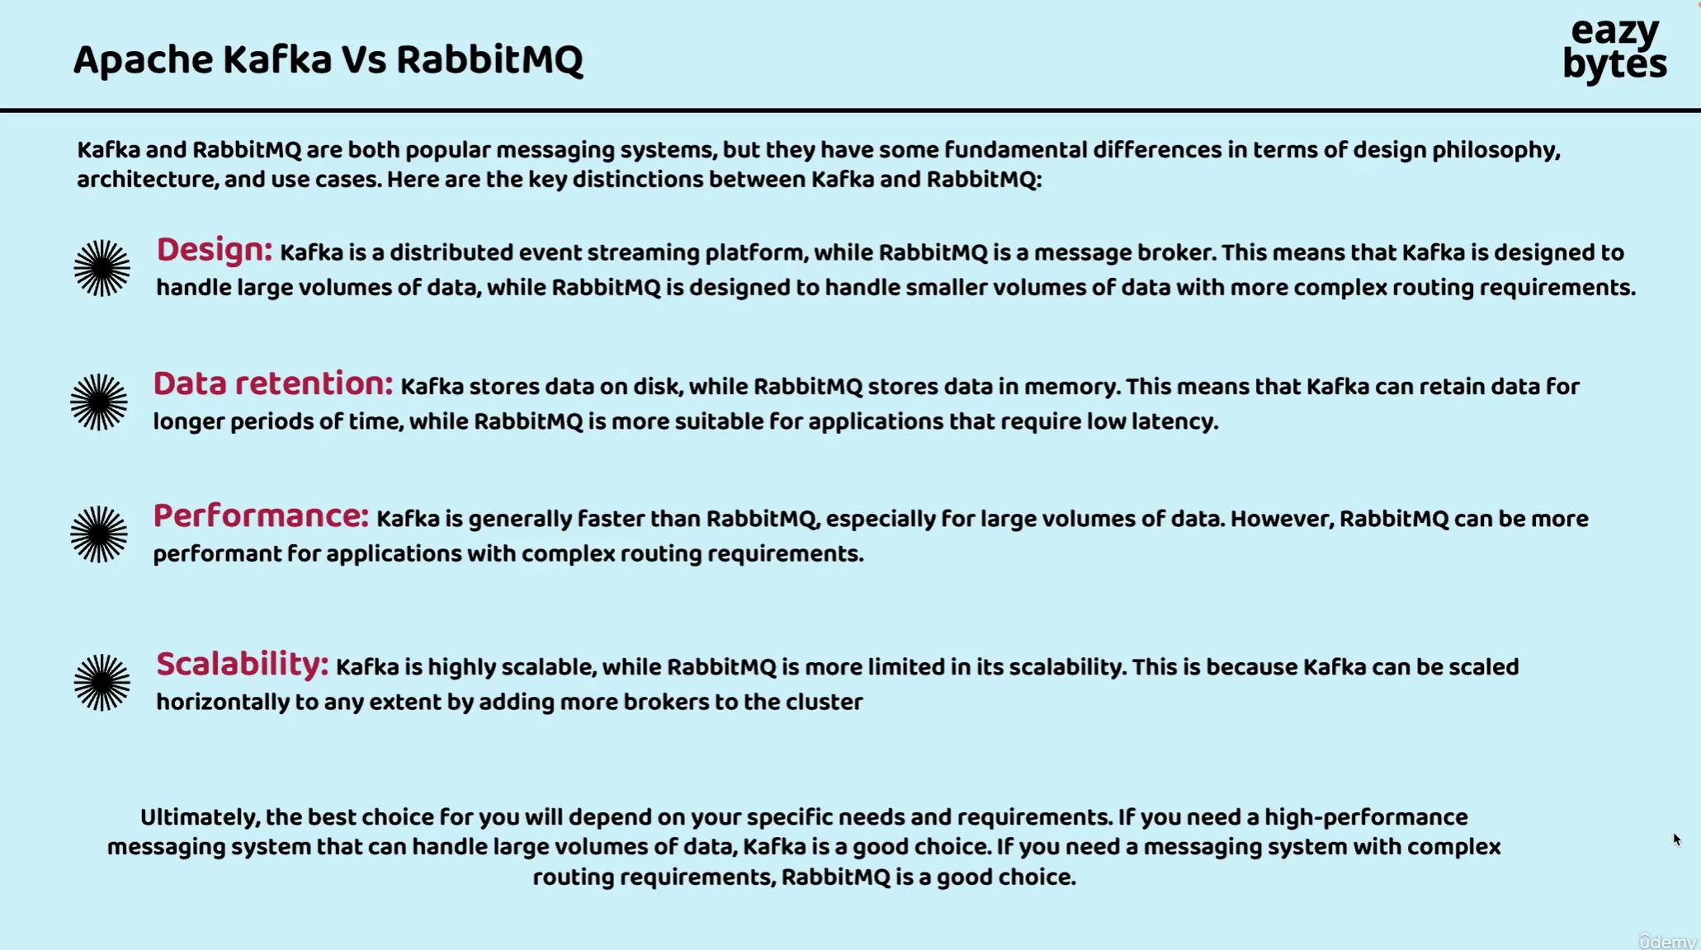

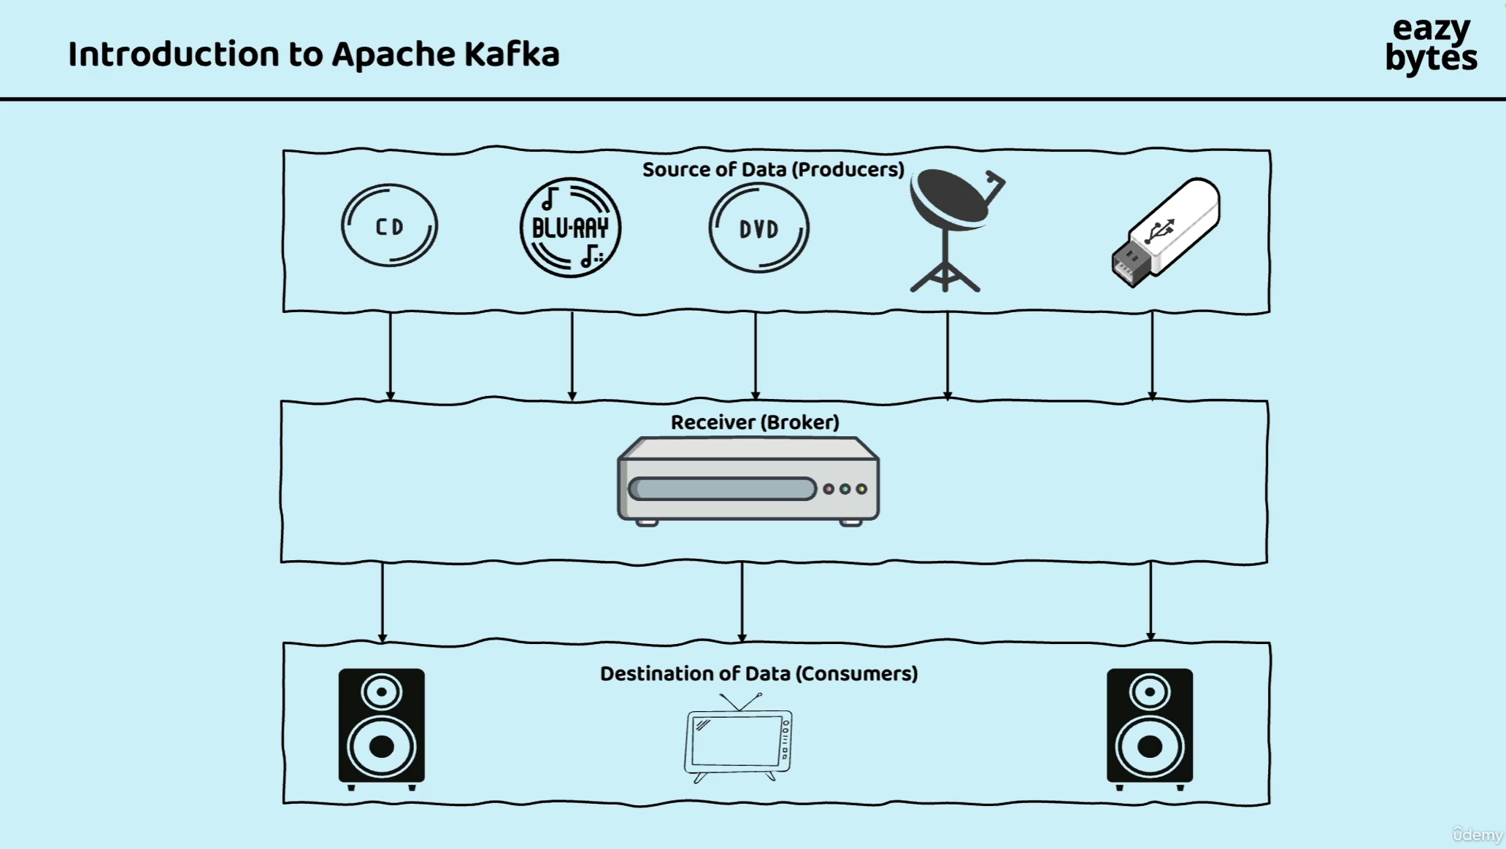

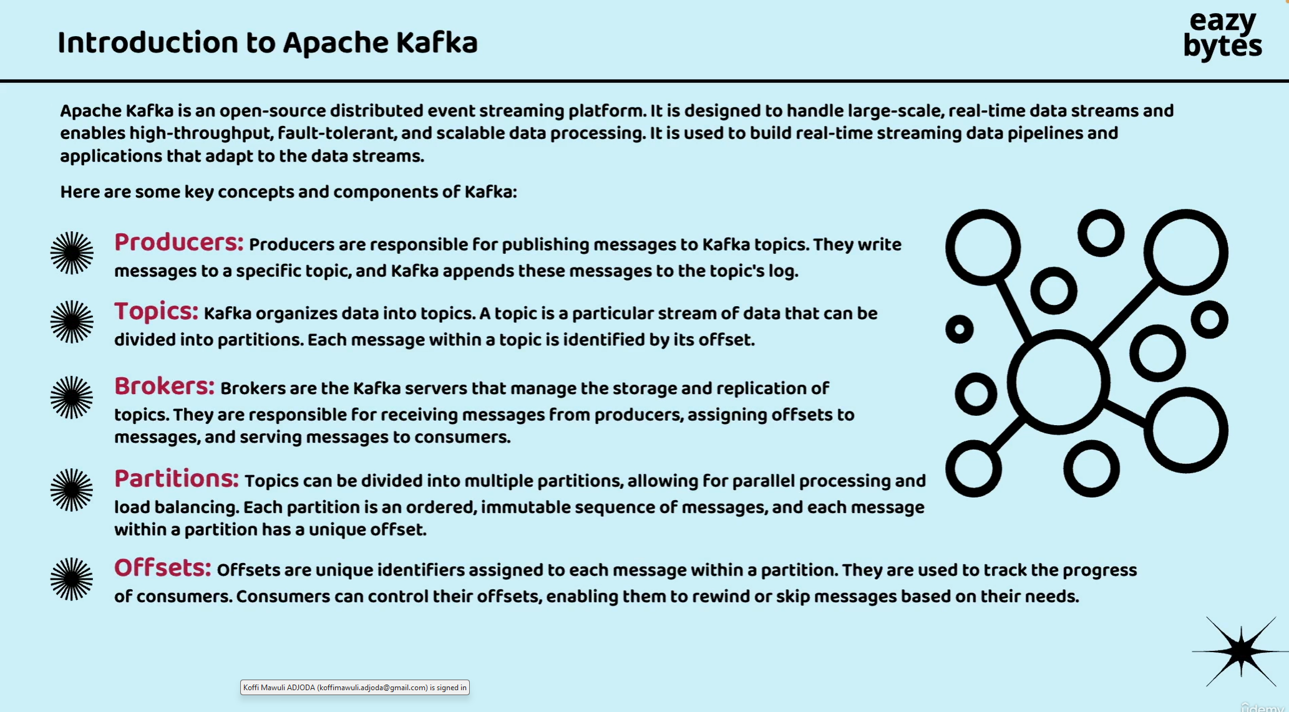

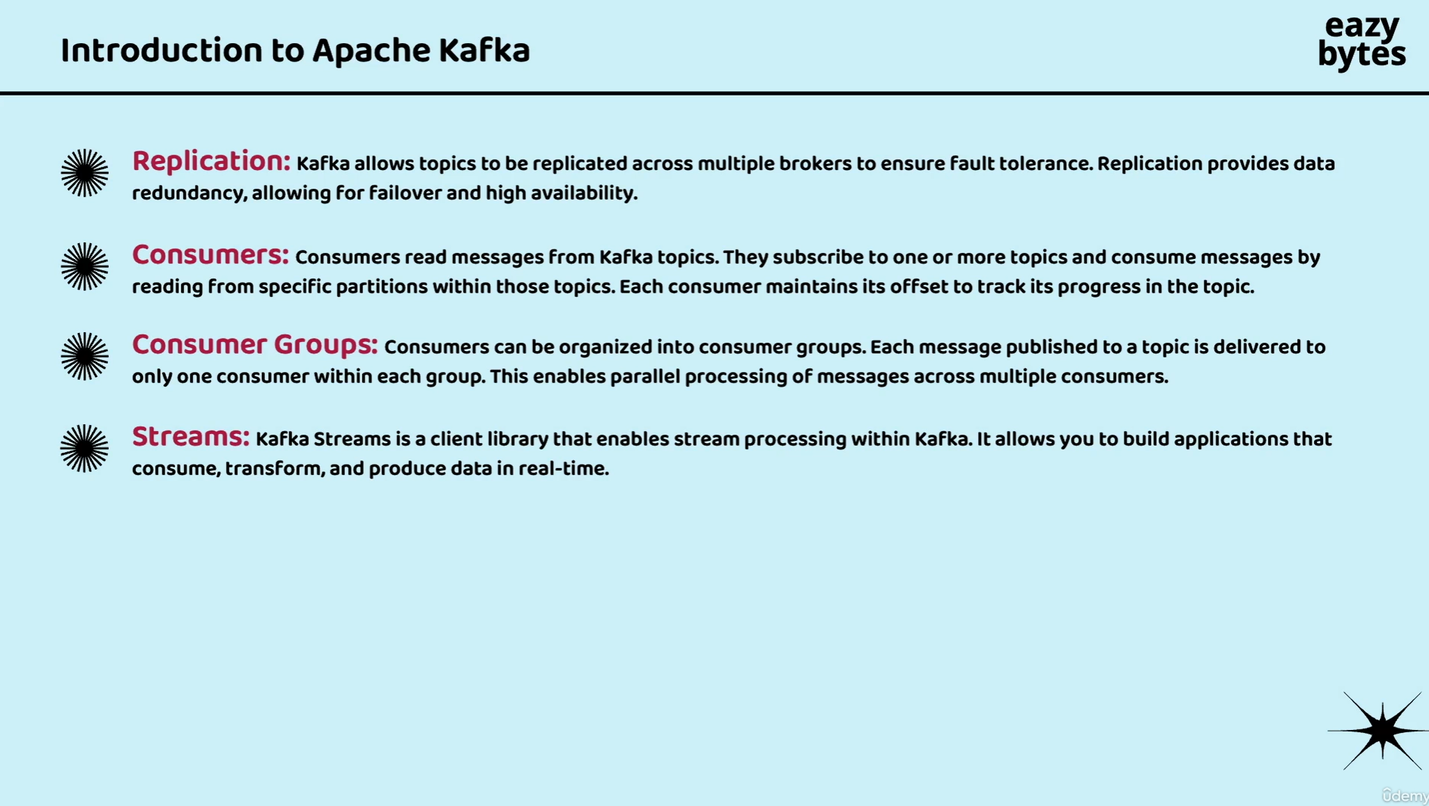

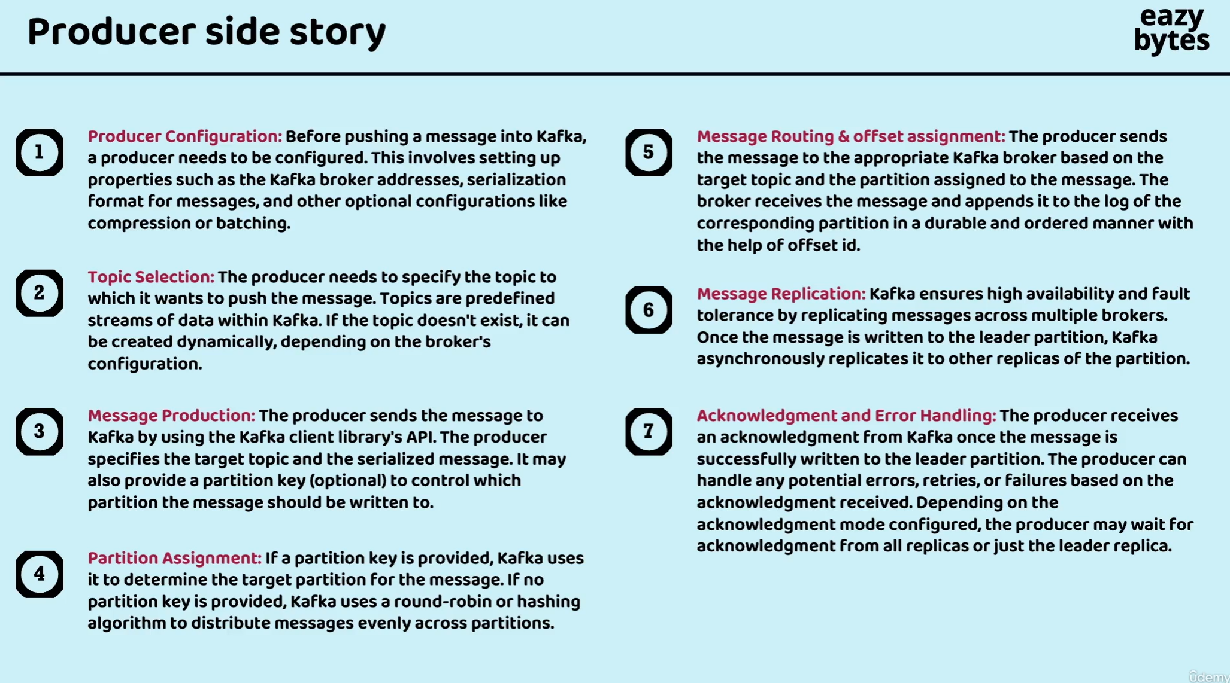

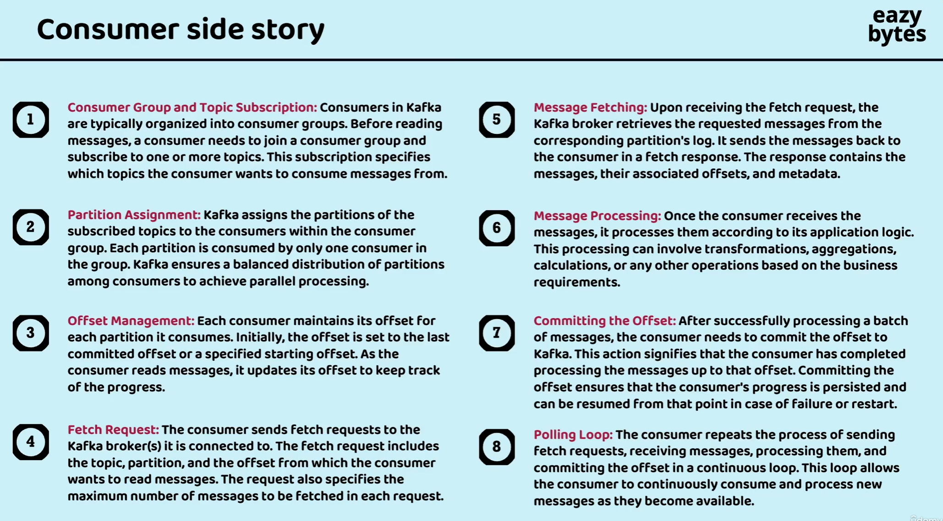

We may feel like this looks very complex to us, like how should we implement such a complex architecture or event driven model inside our microservices?

How should we create a topic, how should we create a partition, how should we create a offset number?

So this sounds super complex to we, but like we said, we have our friend, which is Spring Cloud Stream.

It is going to make this process of setting Apache Kafka super easy.

From that developer perspective, all the infrastructure headache is going to taken care of by the Spring Cloud Stream.

